Project Name
Triple C
Project Idea

“Triple C is a creative marketing agency dedicated to building strong brand identities through strategic marketing, engaging content, and innovative digital solutions. We help businesses connect with their audience, grow their presence, and achieve measurable results across all social media platforms.”

Team Members (pentaRae)
- Hosny Hany (Team Leader)
- Amr Assem
- Mohammed Osama
- Verina Khairy
- Nancy Kamal
- Fahd Abd Elnaby
Work Plan
- Research & Analysis
  - Audience personas
  - Our target audience consists of young individuals aged 18 to 35 who are actively seeking self-development and a better understanding of modern life. They are digitally active, curious, and highly engaged with short-form video content across social media platforms.
  - This audience includes university students, fresh graduates, and early-career professionals who are interested in improving their financial knowledge, maintaining a healthy lifestyle, and staying updated with the latest advancements in artificial intelligence and digital trends.
  - They value content that is simple, practical, and easy to consume. Rather than complex or theoretical information, they prefer actionable insights that can be applied directly to their daily lives.
  - Our audience is driven by growth, whether it is personal, financial, or intellectual. They are looking for guidance that helps them make smarter decisions, adapt to rapid technological changes, and become more aware of social, environmental, and digital responsibilities.
  - Through AI-powered video content, we aim to deliver valuable, engaging, and easy-to-understand awareness that fits their fast-paced digital lifestyle.
- Visual Identity
  - Logo design
  - 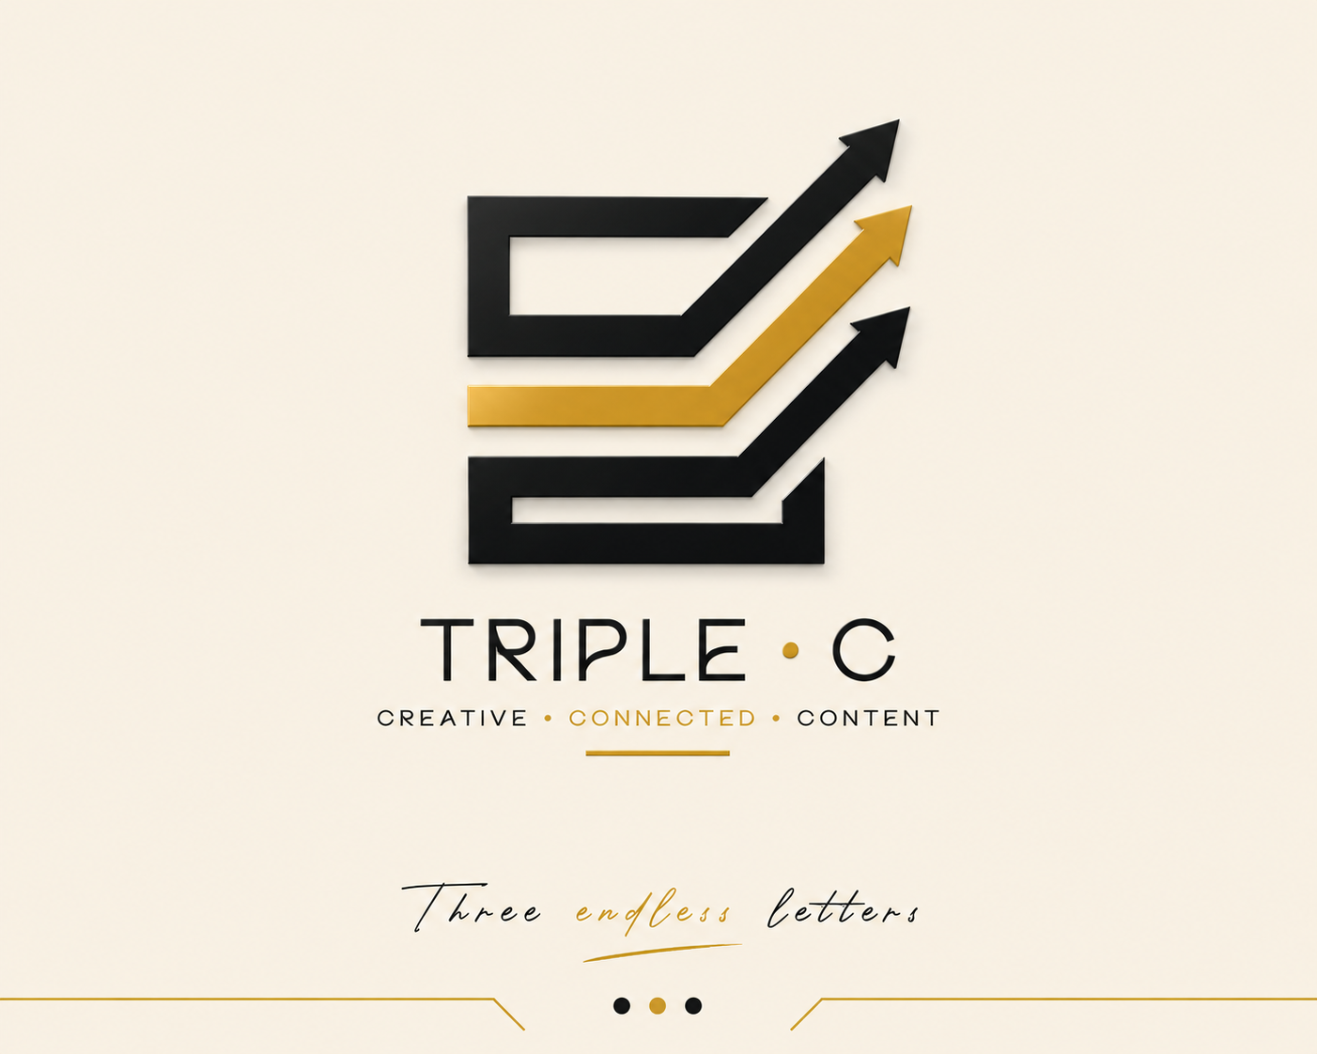
- Main Designs
  - Poster
- Complementary Products
- Review & Finalization
- Final Presentation
Roles & Responsibilities
- KPIs (Key Performance Indicators) – Metrics for project success (e.g., response time, system uptime, user adoption rate).

Instructor
*

Project Files
You can find the full project files here:
--------
License
This project is licensed under the
- KPIs (Key Performance Indicators) – Metrics for project success (e.g., response time, system uptime, user adoption rate).

